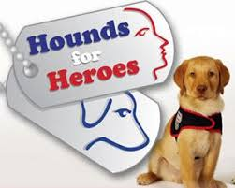**On Friday 22nd November, Donna (a puppy parent) came into our school to tell us about the wonderful charity that we are supporting this year ‘Hounds for Heroes’.**

**Alan Parton started the charity in 2013 because he had a head injury in 1991 while on duty in the Gulf War. Hounds For Heroes helps many people who have been injured in war or on duty and other service people including the police and ambulance crew. Parton had the idea to help these sorts of people by giving them an assistance dog to help them with their everyday activities. Whether it’s closing a door or helping put slippers on, these dogs make everyday jobs just that little bit easier. Hounds For Heroes has trained 35 dogs so far, at the moment 10 are in training and 6 are in advanced training. The charity owns the dogs for the whole of their life so that they can make sure that they are looked after properly.**

**This outstanding charity always trains puppies, they can start training at 8 weeks old, as the younger the puppy is, the easier it is to train. It takes approximately 2 years to train them, and costs £25,000. Hounds For Heroes uses the £25,000 to pay for more equipment, insurance, food, toys and training. Did you know that it costs up to £50,000 to look after the dog through their whole life as a Hounds for Heroes dog? The money we raise this year will be used for training.**

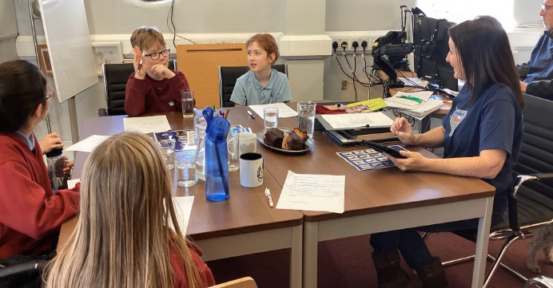**The charity trains Golden Retrievers and Labradors due to them being the perfect height for helping humans. Some of the dogs don’t complete their training, either because they don’t have the skills or they don’t have the right personality to be an assistance dog, so the charity gives them a different job, they might be a demo dog or an ambassador for Hounds for Heroes.**

**The Hounds for Heroes dogs help their owners with daily jobs such as taking off jumpers, gloves etc. The dogs also get trained to pick up keys, open and close drawers and doors. You put a rope on anything that you want them to keep them up, you can say for example Tilly, pick up” and point to what you want them to pick up. They are very clever.**

**This amazing charity has many dogs which are all named after something to do with war or the armed or police services. Here’s some of the names they have called them: Cleo, Hercules, Florence, Comet, Echo, Astra, Alice and Recce.**

**Donna is a puppy parent, so she trains and keeps dogs for 2 years. When they go out to be a Hound for Heroes, they stay a Hound for Heroes dog until they reach the age of 10 which is when they retire.**

**Donna said that Alice and Recce were the naughty ones! Donna remembers Alice and Recce demolishing an outdoor beanbag in her garden which landed in her neighbours’ garden; there are still beanbag beans on the grass even now! She also said that Echo once rolled in fox poo and Chelsea fell into the duck pond, so she hates water now!**

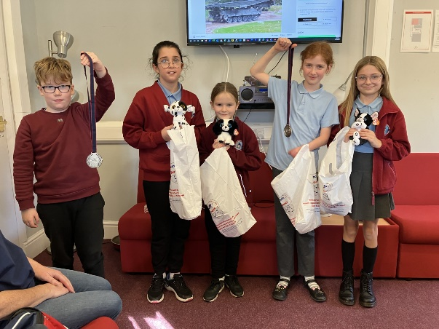**Donna says the best thing about being a volunteer for Hounds For Heroes is meeting people and coming into schools. She also loves training a new puppy. Donna has trained 7 puppies through her time being a puppy parent. Here are some of their names, Echo, Chelsea, Recco, Alice and Flanders.**

**Donna discovered the charity when she was in Petersfield shopping, she saw the dogs being trained. The charity gave her information and told her they were always looking for new volunteers. Later that day on her way home in her car she immediately phoned the charity and asked to be a volunteer and then told her son, who was very excited.**

**Donna enjoys training the puppies, she takes them to puppy training classes 2-3 times a week and teaches them commands. She also takes them out to different places to get them used to it, like the shops, the library, travelling on a train or bus and going on the school run. After 2 years the puppies go onto advanced training, which is 5 times per week, Donna doesn’t go with them then.**

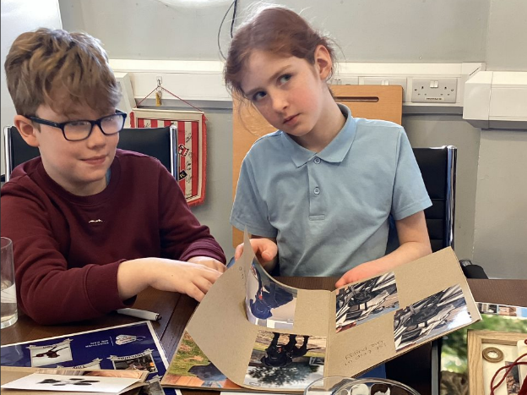**Unfortunately, every time a puppy leaves, Donna is incredibly down hearted as she had spent 2 years with them, but she makes a scrap book and a paw print of them so that she can remember them forever. When a dog leaves to become a partner dog, she doesn’t keep in contact with them as the dog might get confused and want to go back to her and it needs to start its new life. But she does hear how they are getting on.**

**We were very lucky to have Donna coming into Ludlow Junior School to answer all our questions! She enjoys her job so much and we are grateful for her visit.**

**Thank you for reading our report about Hounds for Heroes. ☺**

**Written by Saffron, Victoria, Evie, Xander and Poppy.**